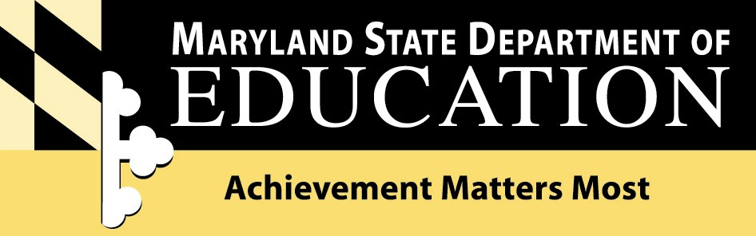

Nancy S. Grasmick
State Superintendent of Schools

200 West Baltimore Street, Baltimore, MD 21201 410-767-0100 410-333-6442 TTY/TDD

TO: Directors of Teacher Education at Community Colleges
Directors of Human Resources
Title I Coordinators

FROM: Lawrence E. Leak, Assistant State Superintendent
Division of Certification and Accreditation

RE: Instructional Paraprofessionals and ParaPro Assessment

DATE: August 20, 2003

This memo is to provide clarification on several issues related to the No Child Left Behind Act (NCLB) and “highly qualified” requirements for instructional paraprofessionals in schools (see Attachment). Specifically, each state receiving Title I funds under Part A of NCLB must develop a plan to ensure that all instructional paraprofessionals working in Title I supported programs hold a high school diploma or GED and have met one of the following requirements to be highly qualified:

- Completed at least two years of study at an institution of higher education; or
- Obtained an associate’s (or higher) degree; or
- Met rigorous standards of quality demonstrated through a state or local assessment of the knowledge of and the ability to assist in the teaching of reading, writing, and mathematics.

Maryland has defined “two years of study at an institution of higher education” as a minimum of 48 credit hours, as recorded on a college or university transcript. At its June 24-25, 2003 meeting, the State Board of Education adopted the new Educational Testing Service’s test for instructional paraprofessionals, ParaPro with the qualifying score of 455.

ParaPro is Maryland’s official state assessment for meeting the instructional paraprofessional requirements of the NCLB. Instructional paraprofessionals who participated in Maryland’s ParaPro pilot in September 2002 have met the federal requirement, if they met the qualifying score of 455 and hold a high school diploma or GED.

Several local school systems are working in partnership with Educational Testing Service (ETS) and are now offering the ParaPro online. With this partnership option, local school systems can schedule ParaPro on demand for their prospective and veteran instructional paraprofessionals. ETS will provide immediate feedback to test takers and local school systems clients. Any local school system interested in participating can contact Dr. Louise Tanney at ltanney@msde.state.md.us.

c: Dr. Carol Ann Baglin
Dr. Joann Carter
Dr. Virginia Pilato
Dr. Joann Ericson
Dr. Louise Tanney
Ms. Francine Sorin
Ms. Sarah Hall
Dr. Kathy Hiatt
Ms. Loretta Johnson

Attachment

