MARYLAND STATE BOARD OF EDUCATION

Dr. Edward L. Root

President

Mr. Dunbar Brooks

Vice President

Dr. Lelia T. Allen

Jo Ann T. Bell
J. Henry Butta
Beverly A. Cooper
Calvin D. Disney
Rev. Clarence A. Hawkins
Dr. Karabelle Pizzigati
Dr. Maria C. Torres-Queral
David F. Tufaro
Brian Williamson (student member)
Nancy S. Grasmick

Secretary/Treasurer of the Board
State Superintendent of Schools

Colleen P. Seremet

Assistant State Superintendent for Instruction

Dixie Stack

Director, Curriculum

Rolf Grafwallner

Coordinator
Early Learning Office

Robert L. Ehrlich

Governor

The Maryland State Department of Education does not discriminate on the basis of race, color, sex, age, national origin, religion, or disability in matters affecting employment or in providing access to programs. For inquiries related to departmental policy, contact the Equity Assurance and Compliance Branch, Maryland State Department of Education, 200 W. Baltimore Street, Baltimore, Maryland 21201. 410.767.0433 (voice) 410.767.0431 (fax) 410.333.6442 (TTY/TDD)

For more information about the contents of this document, contact 410.767.0335.

©Maryland State Department of Education
2005

April 20, 2005

I am very pleased to provide you with the report, Children Entering School Ready to Learn: School Readiness Information for School Year 2004-05. Each year, MSDE informs policymakers and practitioners of what children know and are able to do when they start formal education in kindergarten.

This report, which is unique in its kind nationally, provides a profile of children’s skill levels as they enter school based on the evaluation of their teachers. It includes valuable trend data about the school readiness levels of specific groups of children for the state and each of the 24 jurisdictions in Maryland.

The major results of the report are:

- More children were starting kindergarten better prepared for school than last year. Fifty-eight percent of the entering kindergarten students were evaluated by their teachers as “fully” ready for kindergarten, a three percent increase over the previous year. This statistically significant increase occurred for both the composite score and the results for Language and Literacy. Most notable, the increase in Language and Literacy since 2001-02 has been twelve percent.

- Children from economically disadvantages backgrounds and children with disabilities were making significant progress over last years. However, these student groups are still lagging behind other children their age.

I encourage you to review the report and work with your constituencies in promoting school readiness skills among our youngest learners. Neuro-scientific research has shown that young children’s learning before they enter formal education is an essential foundation for later school success.

Sincerely,
Nancy S. Grasmick
State Superintendent of Schools

TABLE OF CONTENTS

Results for School Year 2004-05 1-2

Availability of 2004-05 School Readiness Report 2

Background 3

Information Reported 3-5

Appendix A:
Work Sampling System (WSS) Kindergarten Checklist: Selected
Performance Indicators for School Readiness Information A1

Appendix B:
School Readiness Information – Introduction to Scoring B1

Presentation of School Readiness Information B2

Definitions B3

School Readiness Information for
- State of Maryland B4

Appendix C:
Frequently Asked Questions C1

Appendix D:
Percentage of Kindergarten Students Assessed as
“Fully Ready” by Domain and Subgroup
2001-02 and 2004-05 D1

Results for School Year 2004-05

More Students are Entering Maryland Classrooms Prepared to Learn

Maryland students entering kindergarten this school year were better prepared than those in the past. The cohort of Maryland’s students entering kindergarten in school year 2004-2005 improved its overall school readiness skills by three (3) percent compared to students who entered kindergarten in the 2003-2004 school year. The percentage of incoming kindergarteners considered by their teachers as “fully ready” went from 55 last year to 58 percent this year. The increase from the baseline year of 2001-02 was nine (9) percent.

The upward trend is a statistically significant shift from school year 2001-02 and reflects the statewide efforts of improving the early learning opportunities for young children as they begin their school career. The results for the domain Language and Literacy are even more pronounced. According to the teachers’ assessment of emergent reading and writing skills, twelve (12) percent more children were rated “fully ready” compared to youngsters who entered kindergarten in 2001-02. The increase from last year was three (3) percent from 45 to 48 percent.

- Improvement in School Readiness is Apparent In Most Demographic Categories

The overall improvements appear for many subgroups. For instance, the school readiness levels for African American kindergarteners improved for the Composite by six (6) percent and the Language and Literacy scores by five (5) percent over last year. The increase for low income children was seven (7) percent for both the Composite and six (6) percent for Language and Literacy scores. The improvement among children with disabilities of two (2) percent for the Composite to 37 percent and one (1) percent for the Language and Literacy scores to 26 percent indicates the continued upward turn in the curve for children with disabilities. However, the composite results for English language learners dropped by three (3) percent from 40 to 37 percent and slightly by one (1) percent in the domain Language and Literacy from 27 to 26 percent.

- Relationship of School Readiness and Prior Early Care Experiences

Each year, local school systems collect information of where children received their early care and education one year prior to kindergarten. The co-called Prior Care categories reflect children who were exclusively enrolled in on of the following early childhood programs: childcare centers, Head Start, non-public nursery, family child care, or public school prekindergarten. In addition, the report includes information about children who were not enrolled in state regulated programs but either stayed home or had informal care by a relative or next-to-kin. Each category represents different demographic groups of children. For instance, public school prekindergarten and Head Start programs are for free and almost exclusively serve low-income children, while the parents of children enrolled in child care and non-public nurseries pay substantial tuition for early care and education.
This year’s cohort of children who have been enrolled in most of the early care and education programs improved slightly over last year’s group of children. For instance, the composite scores for prekindergarten and Head Start children improved by three (3) and one (1) percent respectively. Children who attended child care centers had slightly better composite scores (i.e., two (2) percent) than the entering kindergarteners from last year. A more in-depth report on the relationship between the school readiness results and prior early care experiences, including the results for children from multiple settings, will be released in May 2005.

Availability of the 2004-05 School Readiness Information Report

Data on the Web Site
On April 20, 2005, the school readiness information for school year 2004-05 will be available online at www.marylandpublicschools.org or at the dedicated website for the Maryland Model for School Readiness (MMSR) at www.mdk12.org/instruction/ensure/mmsr. Hard copies of the report are available upon request from the Maryland State Department of Education, Early Learning Office, at 410-767-0335.

Background

The Importance of School Readiness
Recent neuro-scientific research strongly supports the belief that young children’s learning before they enter formal education is an essential foundation for later school success. Increasingly, state policy makers across the country are addressing readiness for school by improving the learning opportunities for young children before they enter school, particularly those who are enrolled in early care and education programs. In addition, many children require necessary family and health support to thrive developmentally.

Charge by the Maryland General Assembly and the Maryland State Board of Education
On January 20, 2000, the Subcabinet for Children, Youth, and Families submitted a report to the Joint Committee on Children, Youth, and Families outlining strategies to improve services for young children and to prepare them to enter school ready to learn. The report states, “if progress toward our goal (of school readiness) is to be made, policymakers must have access to data by which progress may be measured”. In 2001, The Maryland State Board of Education incorporated a school readiness goal in MSDE’s strategic plan, using the annual school readiness information to measure the progress toward this goal. The annual school readiness report has been issued since school year 2001-02.

Alignment of School Readiness Measures with the Maryland Content Standards
The Maryland Content Standards and Voluntary State Curriculum (VSC) are included in the Maryland Model for School Readiness (MMSR) defining early learning standards and indicators of what children should know and are able to do before they start formal education. The MMSR includes as its assessment component the Work Sampling System™ (WSS), a portfolio-based assessment system helping teachers document and evaluate children’s skills, knowledge, behavior, and academic accomplishments across a variety of curricular areas. Through ongoing observation, recording, and evaluating everyday classroom experiences and activities, teachers gain a better understanding of what their students know, are able to do, and what they still need to work on. The WSS™ learning domains which are part of the school readiness information are:

- Social and Personal Development;
- Language and Literacy;
- Mathematical Thinking;
- Scientific Thinking;
- Social Studies;
- The Arts;
- Physical Development and Health.

Information Reported
Kindergarten teachers use the WSS™ with all children throughout the school year. For this report, teachers have provided information on students’ skills for the first grading period in the fall 2004. The fall assessment ratings were done on 30 selected WSS™ performance indicators of the 66 WSS Kindergarten Checklist indicators, reflecting skills and abilities that can reasonably be expected from children when they enter kindergarten. The 30 WSS™ indicators represent the aforementioned seven WSS™ domains (Appendix A) that were used for the school readiness baseline information.

More than 2,000 kindergarten teachers used portfolio-based assessment to document their students’ performance in their classrooms during the first eight weeks of school. Between November 1-12, 2004, the teachers evaluated and rated their students’ performance according to the WSS™ assessment protocol and specific assessment guidelines (“Exemplars”) that were developed by MSDE.
The assessment information in this report reflects scores for each of the seven (7) domains and the composite score of all domains. The information has also been analyzed for each of the seven (7) domains and the composite score by the following demographic information:
- race/ethnicity;
- gender;
- prior early care;
- special education;
- limited English proficiency; and,
- enrollment in free and reduced priced meals program.

Reporting of the scores reflects the percentage of students who have reached one of the following levels of readiness:

Full Readiness: Students consistently demonstrate skills, behaviors, and abilities, which are needed to meet kindergarten expectations successfully.
Approaching Readiness: Students inconsistently demonstrate skills, behaviors, and abilities which are needed to meet kindergarten expectations successfully and require targeted instructional support in specific domains or specific performance indicators.
Developing Readiness: Students do not demonstrate skills, behaviors, and abilities, which are needed to meet kindergarten expectations successfully and require considerable instructional support in several domains or many performance indicators.

School readiness data is reported for:
- Local School Systems and the Edison Partnership Schools
- State of Maryland

Each local school system receives the kindergarten assessment information on individual students, school building, and school system reports in the form of the aforementioned aggregated and disaggregated information. In addition, local school systems receive assessment information on each of the 30 WSS™ indicators of learning.
Determination of Progress
Interpreting the results regarding the readiness levels for specific groups should be evaluated as a way to track progress over time for each domain and each demographic category. For instance, the trend for the domain, Language and Literacy, should be tracked over time by comparing the results from year to year. Any progress is measured at the 95 percent confidence interval. The same measure applies, for example, to determining any significant changes over time for Language and Literacy using specific prior care categories, such as prekindergarten or child care center. Caution must be taken when interpreting the information when relatively small numbers of children are involved. The information presented in this report does not presume any specific causes for the annual changes in the data.

Use of Data and Accountability
The data provides a snapshot of school readiness levels of entering kindergarteners for the state and for each local school system in the fall of each year. The school readiness information is designed for purposes of instructional accountability, i.e., the data should inform practitioners and policymakers of how to improve the learning opportunities for young children and to begin the discourse for improving the quality of early childhood education. In general, the information can be used to:
- Develop a county-wide needs assessment regarding the skill levels of children entering kindergarten.
- Target federal, state, and local funds to address identified needs in the county.
- Develop forums for partnership building.
- Modify curricular and intervention programs and to identify resources for kindergarten.

Validity and Reliability of Data
Since Maryland’s kindergarten teachers are using a portfolio-based assessment to evaluate their students’ skill levels, any concerns about the subjectivity of the teachers’ evaluations must be addressed. The school readiness information is based on formative and summative evaluation protocols. The summative evaluations in the fall include the students’ observed and documented records of their skills, behavior, and knowledge in response to the introduction of the kindergarten curriculum. The teachers are trained in the use of specific guidelines which define fall benchmarks of kindergarten expectations for each of the 30 WSS™ indicators of learning. The indicators for the WSS™ domains language and literacy, mathematical and scientific thinking, as well as social studies are aligned with the Maryland Content Standards and the state’s Voluntary State Curriulum. Any sampling error of the results are eliminated by implementing census administration of the WSS™. In addition, each year the analyzed data is being verified by each local school system as well as an independent vendor who also provides reliability analyses for the state and county data sets.

APPENDIX A

Work Sampling System (WSS)
Kindergarten Checklist: Selected Performance
Indicators for School Readiness Information
Work Sampling System (WSS) Kindergarten Checklist: Selected Performance Indicators for School Readiness Baseline Information

Introduction: The Maryland Model for School Readiness (MMSR) uses the Work Sampling System (WSS) Kindergarten Checklist to assess entering kindergartners’ readiness levels. A selected set of 30 WSS indicators across seven curricular domains describe skills, behaviors, and knowledge of children who are entering kindergarten. The 30 WSS indicators below are briefly described. Teachers systematically observe their students, document their learning, and rate their competencies using specific WSS Kindergarten Developmental Guidelines associated with these indicators.

I Social and Personal

SELF-CONCEPT
Shows initiative and self-direction. | Independence in thinking and action enables children to take responsibility for themselves. Most five year olds can make choices among familiar activities, participate in new experiences, and are willing to take some risks.
SELF-CONTROL
Follows classroom rules and routines. | Children who are successful within a group know and accept the rules established for that particular group.
Uses classroom materials purposefully and respectfully. | One of the major challenges of school for five year olds is learning how to care for classroom materials. With some reminders, a child learns how to use materials thoughtfully (so the materials continue to be available for others) and how to put things away so that others can easily find them.
INTERACTION WITH OTHERS
Interacts easily with one or more children. | Kindergarten children are beginning to play cooperatively with one or more children, listen to peers and understand their feelings, and solve problems cooperatively.

II Language and Literacy

LISTENING
Gains meaning by listening. | Young children are actively involved in learning about their world by watching and listening. At five years, children can listen for meaning in such different situations as one-on-one conversations with children or adults, small and large group activities, story times, and videos.
Demonstrates beginning phonemic awareness. | With frequent demonstrations by the teacher, children recognize and produce rhyming words, identify beginning and ending sounds, and begin to discriminate the smaller parts of words, first distinguishing syllables and, later, sound within syllables.
SPEAKING
Speaks clearly and conveys ideas effectively. | During kindergarten, children begin to understand how to express their ideas in group discussions as well as in one-to-one conversations.
READING
Shows some understanding of concepts about print. | Kindergartners realize that print conveys meaning, spoken language can be written down and read, and certain words are always written the same way.
Comprehends and responds to fiction and non-fiction text. | Kindergartners demonstrate their understanding of what they hear by answering questions about the text, predicting what will happen next using pictures and content for guides, and retelling information from a story in sequence, adding more details and story elements over time.
WRITING
Uses letter-like shapes, symbols, letters, and words to convey meaning. | Children begin using drawings to convey ideas, adding letters or words randomly to their written communication.

III Mathematical Thinking

MATHEMATICAL PROCESSES
Begins to use and explain strategies to solve mathematical problems. | Young children solve problems and explain their reasoning by working with concrete objects, drawing pictures, or acting out solutions.
NUMBERS AND OPERATIONS
Shows understanding of number and quantity. | Kindergarten children can count objects to at least 20; many learn to count verbally (that is, by rote) to 100. They can count using one-to-one correspondence reliably, use objects to represent numbers, and use numerals to represent quantities.
PATTERNS, RELATIONSHIPS, AND FUNCTIONS
Recognizes duplicates and extends patterns. | Kindergartners can recognize, create, copy, and extend simple patterns using concrete objects, sounds and physical movements.
GEOMETRY AND SPATIAL RELATIONS
Recognizes and describes some attributes of shapes. | As children play with unit blocks, table blocks, pattern blocks, shape sorters, peg boards, and geoboards, they gain a concrete understanding of shape and form.

IV Scientific Thinking

INQUIRY
Seeks information through observation, exploration, and descriptive investigations. | As questions are raised, kindergartens seek answers primarily through exploration, manipulation, and careful observation using their senses.
Uses simple tools and equipment to extend the senses and gather data. | Although kindergarteners begin to observe using their five senses, they are very intrigued with tools that extend the power of their senses and that they associate with grown-up activities. Scientific tools include magnifiers, gears and pulleys, calculators and computers, and simple balance scales and rulers.
PHYSICAL SCIENCE
Identifies, describes, and compares properties of objects. | With prompts from the teacher, five year olds notice what things are made of and describe numerous attributes of objects including size, shape, color, texture, weight, temperature, whether objects are attracted or unaffected by magnets, and whether various objects sink or float.
LIFE SCIENCE
Demonstrates awareness of the reasons for rules. | Children’s understanding of the reasons for the rules and laws comes about as they discuss problems in the classroom and school and participate in making reasonable rules that directly involve them.

V Social Studies

PEOPLE, PAST AND PRESENT
Identifies similarities and differences in people’s characteristics, habits, and living patterns. | Kindergartners develop self-identity by comparing themselves with others.
HUMAN INTERDEPENDENCE
Describes some people’s jobs and what is required to perform them. | Young children are ready to examine their communities and explore the many roles people fill in helping each other live.
Begins to be aware of technology and how it affects life. | Kindergartners are very interested in the technology that is so much a part of the world around them (television, telephones, vehicles, video games, VCRs, microwave ovens, computers).
CITIZENSHIP AND GOVERNMENT
Demonstrates awareness of the reasons for rules. | Children’s understanding of the reasons for rules and laws comes about as they discuss problems in the classroom and school and participate in making reasonable rules that directly involve them.

VI The Arts

EXPRESSION AND REPRESENTATION
Participates in group music experience. | Young children enjoy singing, making up silly and rhyming verses, using instruments, learning finger plays, and using music to tell stories and express feelings.
Participates in creative movement, dance, and drama. | Young children are very active and need opportunities to move and stretch their bodies.
Uses a variety of art materials to explore and express ideas and emotions. | Kindergartners need and enjoy opportunities to explore using a variety of art materials.
UNDERSTANDING AND APPRECIATION
Respond to artistic creations or events | Kindergarteners are able to appreciate the artistic creations of others, the skill of a dancer, or someone’s ability to play a musical instrument.

VII Physical Development and Health

GROSS MOTOR DEVELOPMENT
Moves with balance and control. | Young children are very active, seeming to be in constant motion. Kindergarten children can run smoothly, hop many times on each foot, and climb up and down stairs using alternating feet.
FINE MOTOR DEVELOPMENT
Uses eye-hand coordination to perform tasks effectively. | Kindergartners are continuing to improve their eye-hand coordination and accomplishing tasks with greater precision.
PERSONAL HEALTH AND SAFETY
Performs self-care tasks competently. | Kindergartners are quite competent about taking care of their own physical needs and often volunteer to help classmates who are struggling with buttons and laces.
Shows beginning understanding of and follows health and safety rules. | Kindergartners are interested in health and safety issues, especially when these relate to their own experiences.

Based upon the Work Sampling System® by Pearson Early Learning. All adaptations to Work Sampling System by the State of Maryland are the property of Pearson Early Learning

APPENDIX B

School Readiness Information:
Introduction to Scoring

Presentation of School Readiness Information

Definitions

School Readiness Information for:
Maryland

Introduction to Scoring

The scoring of the 30 selected Work Sampling System (WSS) indicators for kindergarten, representing seven curricular domains, was done by classroom teachers assigning one of three ratings, Proficient, In process or Needs Development, in each of four indicators within six domains and six indicators within the domain, Language and Literacy. Thus, a student is being evaluated for 30 specific skills and behaviors that are aggregated into the domains of Social and Personal, Language and Literacy, Mathematical Thinking, Scientific Thinking, Social Studies, The Arts, and Physical Development. In addition, a composite score, representing all seven domains, was created. In the aggregated format, the scores reflect school readiness levels. The following specific steps were taken to create scoring scales for each domain and the composite.

- Each of the scores at the indicator level was given the following values.
- Proficient = 3
- In Process = 2
- Needs Development = 1

- The sum is calculated for the four indicator values from six of the domains and the six indicator values from Language and Literacy.

- The sums were then divided into three readiness levels.
For Language and Literacy:
- Full Readiness = sums of 18, 17, 16 & 15
- Approaching Readiness = 14, 13, 12, 11 & 10
- Developing Readiness = 9, 8, 7 & 6

For the Domains with 4 Indicators
- Full Readiness = sums of 12, 11 & 10
- Approaching Readiness = sums of 9, 8 & 7
- Developing Readiness = 6, 5 & 4

- The following definitions were developed for the readiness levels.
- Full Readiness: Students consistently demonstrate skills, behaviors, and abilities needed to meet kindergarten expectations successfully.
- Approaching Readiness: Students inconsistently demonstrate skills, behaviors, and abilities needed to meet kindergarten expectations successfully and require targeted instructional support in specific domains or specific performance indicators.
- Developing Readiness: Students do not demonstrate skills, behaviors, and abilities needed to meet kindergarten expectations successfully and require considerable instructional support in several domains or many performance indicators.

5. A similar process allows for all indicator values to be summed across domains and then place in the same three proficiency levels with the following values.
- Full Readiness = sums of 71 through 90
- Approaching Readiness = sums of 50 through 70
- Developing Readiness = sums of 30 through 49

It is with the categories of Full, Approaching and Developing Readiness within domains and at the composite level that all data are reported.

Presentation of School Readiness Information

There is a five-page report on the school readiness information for the state of Maryland.

The first chart provides the percentage of students across the three readiness levels for each of the seven domains and the composite of the domains. The bar graphs describe the percentages of entering kindergarten students whose scores fall into any of the three readiness levels (i.e., full, approaching, developing readiness levels).

The second page with the table provides the disaggregation of the same information for each of the seven domains and the composite of the domains by the following demographic variables:
- Race/ethnicity
- Gender
- Prior care
- Students with disabilities in special education
- Students with limited English proficiency
- Students enrolled in the free and reduced priced meals program
This table breaks out the information from the aforementioned first chart into percentages of students for each of the readiness levels by domain and the composite of domains.

The third chart lists the number of kindergarten students in each category. Note that the number of students (i.e., cases used to compute the percentages) differs among the domains and the composite. The difference is explained as errors in completing the assessment forms (e.g., incorrect markings on the scanned forms, damaged forms, or missed items.)

The two charts on the fourth and fifth pages describe the composite scores, which appear on the right hand side of the previous table and present them as bar graphs.

Local school systems received school readiness information for each of their elementary schools.

For additional information contact:

Maryland State Department of Education
Division of Instruction
Early Learning Office
200 West Baltimore St.
Baltimore, MD 21201
410-767-0335

Definitions

- Composite Score. The ratings for the seven domains are combined to provide an overall measure of school readiness.

- Prior Care. The categories of early care and education are considered as they impact on school readiness. Prior care reflects kindergarten students’ enrollment within 12 months prior to starting kindergarten. The prior care types are as follows:

1. Head Start. A federal pre-school program for 2 to 5 year olds from low-income families; funded by the US Department of Health and Human Services and licensed by the Maryland Department of Human Resources/Child Care Administration and/or local boards of education.
- Prekindergarten. Public school prekindergarten education for four-year old children. Administered by local boards of education and regulated by the Maryland State Department of Education (MSDE).
- Child Care Center. Child care provided in a facility, usually non-residential, for part or all of the day that provides care to children in the absence of the parent. The centers are licensed by the Maryland Department of Human Resources/Child Care Administration.
- Family Child Care. Regulated care given to a child younger than 13-years old, in place of parental care for less than 24 hours a day, in a residence other than the child’s residence and for which the provider is paid. Family child care is regulated by the Maryland Department of Human Resources/Child Care Administration.
- Non-Public Nursery School. Pre-school programs with an “education” focus for 3 and 4-year olds; approved or exempted by MSDE; usually part-day, nine months a year.
- Home/Informal Care. Care by parent(s) or a relative.

  - Students Receiving Special Services. The following categories of special services are reported for the Kindergarten students.

  - Limited English Proficient (LEP). Students who are not born in the United States (US) or whose native language is a language other than English or no age appropriate ability to understand, speak, read, or write English.

  - Special Education. Students with disabilities who receive special education services and have a current Individualized Education Plan (IEP).

  - Free or Reduced Priced Meals. Students whose applications meet family size and income guidelines for receiving free or reduced priced meals based on the United States Department of Agriculture (USDA) guidelines.

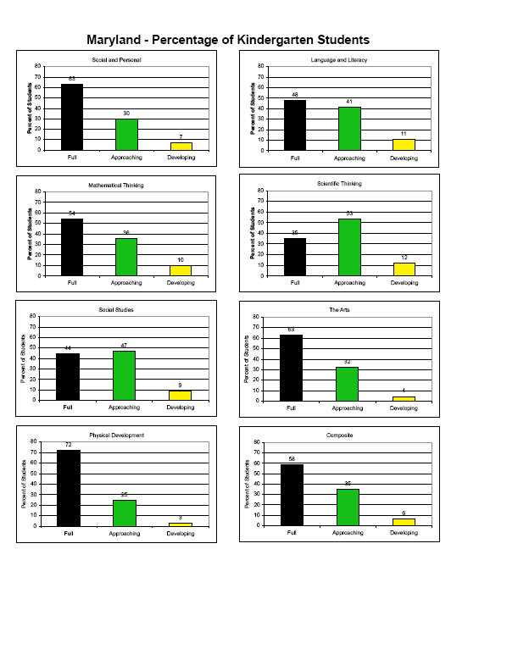

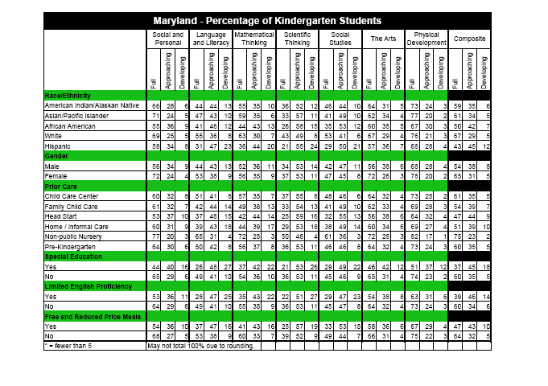
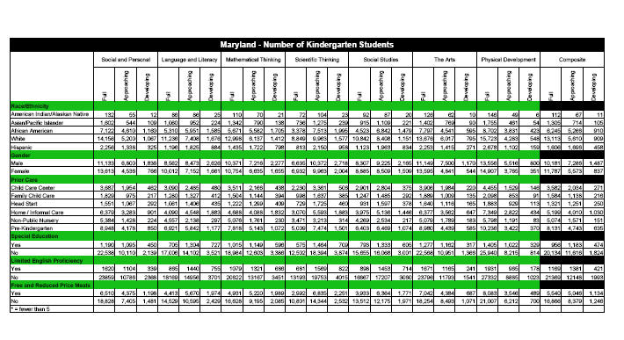

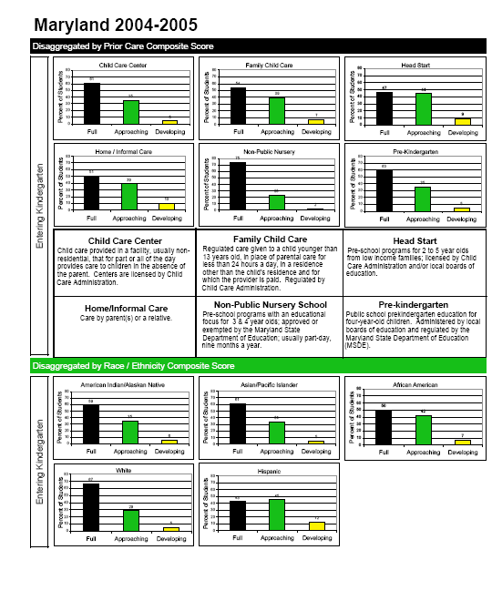
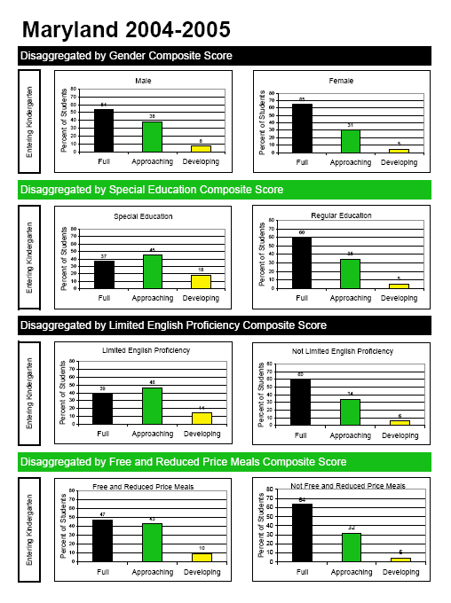

APPENDIX C

Frequently Asked Questions

Appendix C

Frequently Asked Questions

- Why is the school readiness information collected and reported annually?
The Maryland General Assembly is interested in improving services for young children to prepare them to enter school ready to learn. Several legislative committees want to know what children know and are able to do when they enter school. This has necessitated school readiness data at the entry into kindergarten. Collecting evaluation information on all entering kindergarten students will enable policymakers and other stakeholders to have access to data by which progress can be measured over time. The Maryland State Department of Education (MSDE) was the state agency charged with implementing an assessment system for kindergarten. It is required to report this information to the General Assembly in February of each year.

- How is the information collected?
All kindergarten teachers evaluate and rate their students’ proficiency on 30 selected indicators of the Work Sampling System™ (WSS) Kindergarten Checklist. This information is aggregated and disaggregated, i.e., broken out, into the data displayed in this report. According to a statewide teacher survey asking for the preferred way of collecting assessment information, 58% of all respondents keep personal notes and children’s work in a file or container, 14% keep observational data and work samples by domains of learning.

- What is the advantage of using performance-based assessment rather than a norm-referenced test to measure school readiness?
Performance-based assessments measure demonstrated skills, knowledge, and behaviors in an actual learning setting such as a kindergarten classroom. When measuring readiness for school, all developmental skill areas are important. Qualified kindergarten teachers, properly trained and prepared, are an excellent source of information for their students. They assess children’s skills against established standards of learning. On the other hand, norm-referenced readiness tests compare a group of children against a national norm. At the kindergarten level, national norms are difficult to obtain and typically do not reflect all developmental skill levels.

- Why are entering kindergartners assessed over several weeks and not during the first week in school?
In order to learn more about the skills and dispositions of entering kindergartners, the assessment protocol for the data in this report takes into account the following:
Young children need a familiar and comfortable setting to show what they know and are able to do.
Teachers are looking for multiple sources of documentation of children’s learning which are collected over a period of time.
The Work Sampling System™ (WSS) requires teachers to assess their students’ performance in response to the instructional program during the first few weeks of school.

- What does the school readiness information mean?
The information describes the skills, knowledge, and behaviors of children as they enter public school kindergarten programs. The assessment is based on performance indicators that define valid skills and competencies for that age group of children based on research and national standards of learning. The school readiness baseline information is broken into three categories of full, approaching, and developing readiness. (See Questions 6 to 8)

This information is designed to provide a profile on the readiness levels of a group of children for parents, policymakers, schools, early care and education service providers (e.g., child care, Head Start, prekindergarten, etc.), community-based organizations, and the public at large. This information, in combination with other valuable data, will better inform those who are planning to improve the learning opportunities and services for young children.

- What does full readiness mean? Does it mean perfect scores?
Full readiness means that students consistently demonstrate skills, behaviors, and abilities which are needed to meet kindergarten expectations successfully.
A student need not score proficient in all indicators within a domain or the composite to be rated at full readiness. The top range of scores is considered full readiness. (See Introduction to Scoring in Appendix B.)

- What does approaching readiness, mean?
Approaching readiness means that students inconsistently demonstrate skills, behaviors, and abilities which are needed to meet kindergarten expectations successfully and require targeted instructional support in specific domains or specific performance indicators. The middle range of scores is considered approaching readiness. (See Introduction to Scoring in Appendix B.)

- What does developing readiness, mean?
Developing readiness means that students do not demonstrate skills, behaviors, and abilities which are needed to meet kindergarten expectations successfully and require considerable instructional support in several domains or many performance indicators. The bottom range of scores is considered developing readiness.

Note: Teachers either rate students Proficient, In Process, or Needs Development. The categories specified above refer to the aggregated score for each domain and composite.

- Is the information used to place children in special programs?
No. The kindergarten teacher uses the information on children for instructional planning in the classroom. Policymakers, program supervisors, and administrators can use the information from this report for program planning purposes.

- Is the information used to rate kindergarten teachers’ performance?
No. This is used for program and instructional planning. Kindergarten teachers provide information about children as they enter kindergarten. The assessment information is not a reflection on their performance.

- How are teachers using the information?
Based on teacher responses statewide in school year 2002 – 2003, the assessment information is used as follows (percentage in parenthesis):
Helps teachers know what they need to do with certain children (92%)
Helps them determine how to group children (78%)
Used for reporting purposes to parents (86%)
Used when referring student to inter-disciplinary teams for further evaluation (68%)
Helpful when completing the local kindergarten report card (80%)
Results reflect multiple teacher responses.

- How are school officials using the information?
School officials, including building administrators and school improvement teams, are able to look at a profile of readiness levels in a school’s kindergarten program. This review of the data could impact program development, materials expenditures, and staff training.

- How are county officials using the information?
As county officials consider the early education opportunities within the county and the funding necessary to provide a strong kindergarten program, this data will identify needs upon which decision can be made. Service providers (e.g., child care, prekindergarten, homevisiting, or Head Start programs) that work with young children before they come to kindergarten can review the data to align their programs with kindergarten.

- How are state officials using the information?
State officials use this data to make informed decisions about the result area, Children Entering School Ready to Learn, for state policy and budget projections. Also, state officials use the data to facilitate the planning process at the local levels.

- How are parents using the information?
Kindergarten teachers share the assessment information with parents in the fall as part of regularly scheduled parent-teacher conferences. Sharing this information provides a profile of each child’s needs and strengths and serves as communication to support children’s learning both in school and at home.

How are changes from one year to the next explained?
Each year a different group of kindergarten students is being evaluated. This year’s group of kindergarten students, or their respective subgroups, might look slightly different from groups from previous years. For instance, the degree to which a relatively small group of English language learners is proficient in English might vary from year to year and impact the results. When using the data, it is always helpful to check the actual number of students for each category in addition to the percentage breakout to check major increases or decreases in the data. As a rule, any changes are statistically more volatile when small number of students is involved. Since change is defined statistically as any difference within the 95 percent confidence level, any significant change with relatively small number of children could be relatively large. The changes could also be explained as a result of programmatic or instructional improvements which account for differences. Some of these improvements are more likely to show up in the results of specific domains of learning. For instance, specific instructional approaches in early literacy will most likely impact the domain of Language and Literacy. At any rate, when explaining changes in the data, always consult additional assessment data, if available, or seek information from teachers who have worked with the students.

- What safeguards have been put in place to make sure that the teacher ratings are reliable and valid?
The following features have been developed to ensure that the teacher information reflects a consistent application of the assessment protocol:
MSDE has developed a professional development program for all kindergarten teachers using expert consultants who have been trained and properly oriented. The program uses consistent training materials and evaluation forms to determine the effect of each professional development session. As a result of these efforts, teachers are improving their skills of observation, systematic documentation, and evaluation of students’ learning.
MSDE has produced specified guidelines, for rating students’ performances.
During the professional development program, teachers’ accuracy in rating students’ skills and abilities is assessed.
After a national testing company scans the student assessment information, the data is reviewed and examined for internal consistency, correlations, and possible irregularities or unusual performances.

  - Work Sampling System is a registered trademark of Pearson Education

APPENDIX D

Percentage of Kindergarten Students Assessed as
“Fully Ready”
By Domain and Subgroup

2001-02 and 2004-05
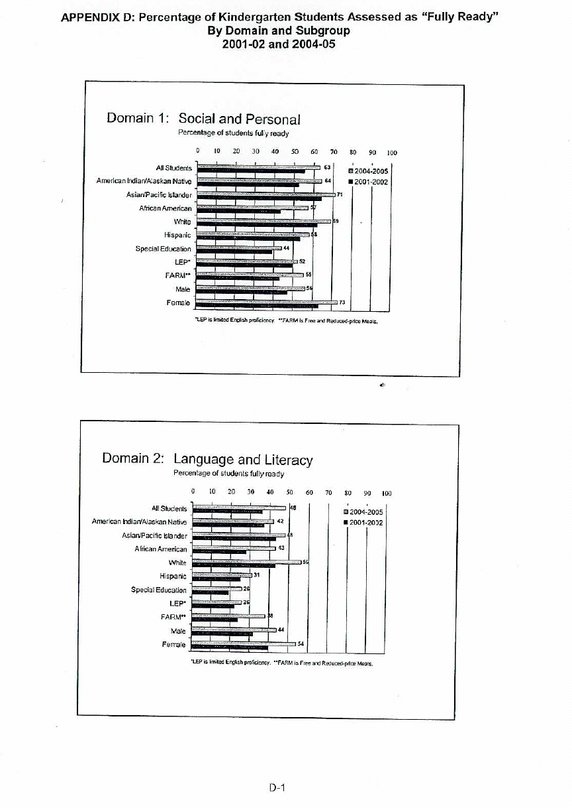
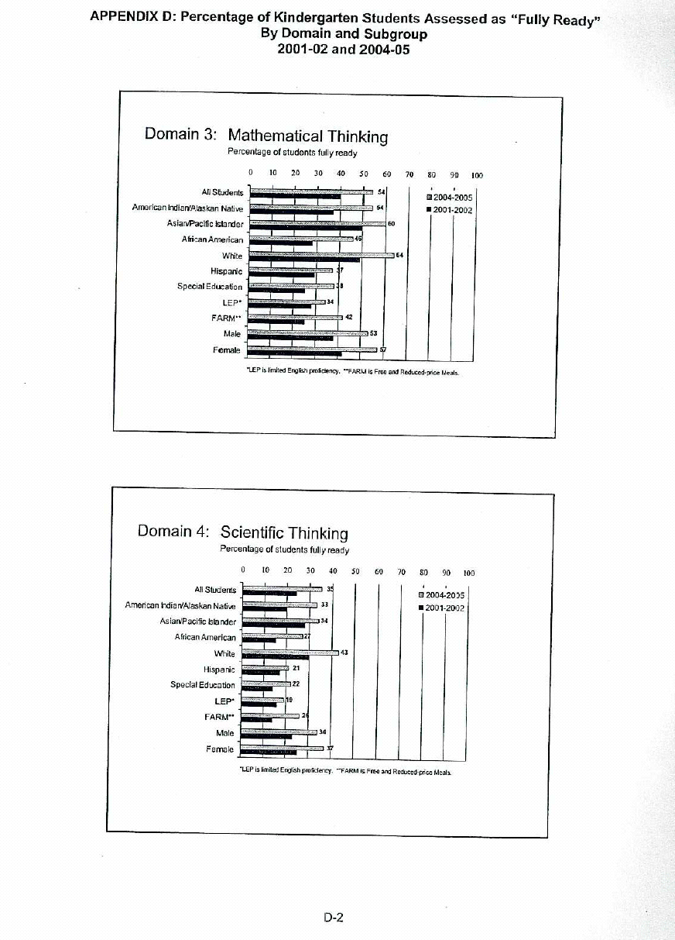
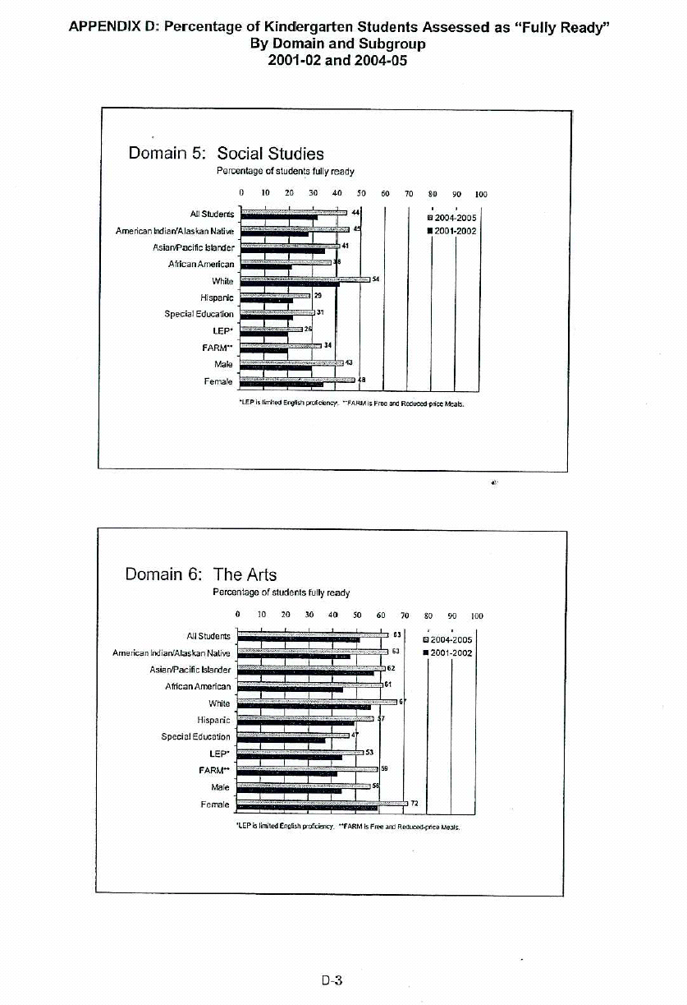
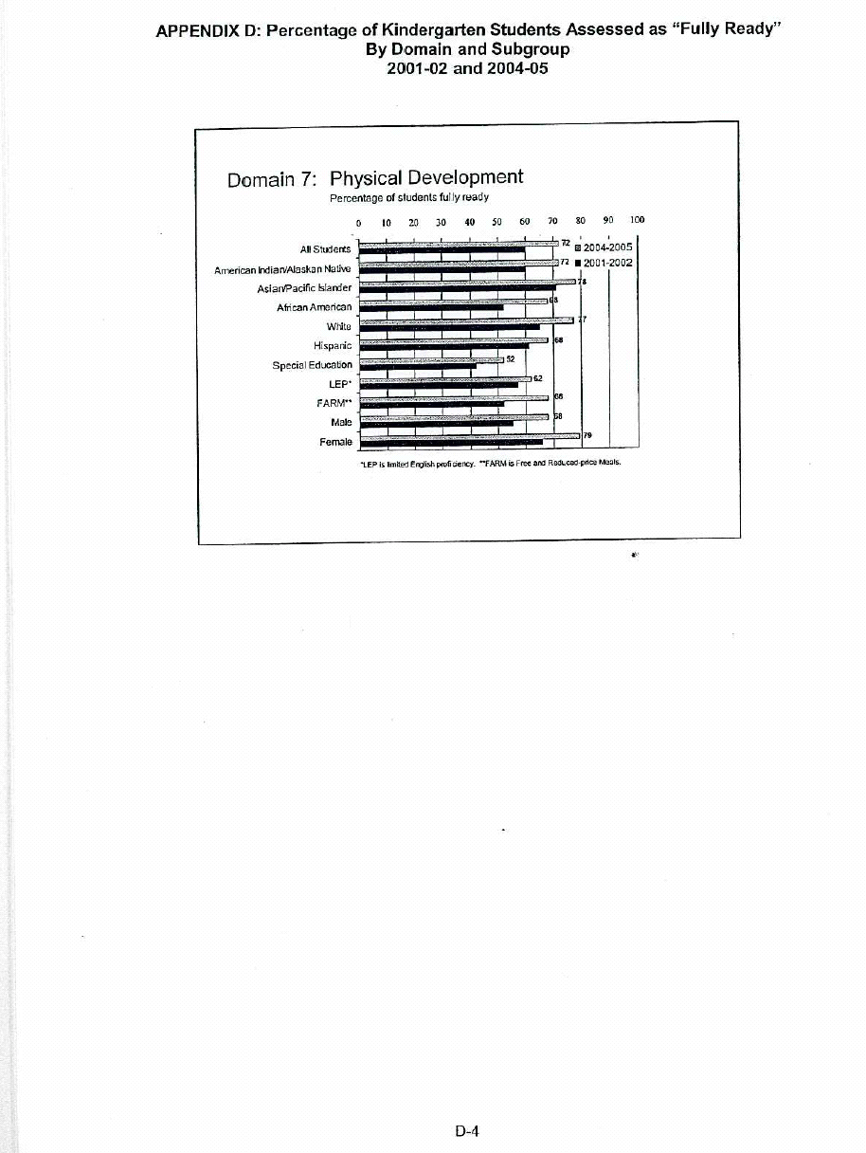

Several local school systems have the WSS indicators integrated into their kindergarten report cards.
This information describes the percentage of students who had their most recent (i.e., 12 months), predominant, and structured early care experience in the following types of programs: child care center; family child care, Head Start, nursery school, public school prekindergarten, or had their prior experience at home or in some type of informal care with a relative. A report on children in multiple settings of early care will be available in May 2005.
This information describes the percentage of students assessed who receive special education services and have an Individual Education Plan (IEP).
This information describes the percentage of students who have a primary or home language other than English and limited or no age-appropriate ability to understand, speak, read, or write English.
This information describes the percentage of students whose application meet the family size and income guidelines of the U.S. Department of Agriculture School Lunch Program for the categories “free” and “reduced” price meals.
See Introduction to Scoring on p. B1
A program to test the difference between two proportions was made available to all local school systems
The specific guidelines, MMSR Fall Performance Examples, describe exemplars of student behaviors in terms of rubrics established for the WSS rating scale.
The reliability analysis includes (a) correlation analysis to identify the degree of association between the student scores and school scores; (b) linear regression analysis to determine the relative effect of each domain on the total score; (c) reliability coefficients to measure the inner consistency of the assessment; and (d) item-scale analysis to determine the relative influence of each item on the assessment. The results of the reliability analyses regarding the school readiness information for school year 2004-05 are available at MSDE’s Early Learning Office.
Maryland State Content Standards and Voluntary State Curriculum for Kindergarten

